

SEND Information Report 2025-26

Introduction

All Nottinghamshire Local Authority (LA) maintained schools and most academies have a similar approach to meeting the needs of pupils with Special Educational Needs and are supported by the LA to ensure that all pupils, regardless of their specific needs, make the best possible progress in school.

All schools are supported to be as inclusive as possible, with the needs of pupils with Special Educational Needs and Disabilities being met in a mainstream setting wherever possible.

What is the Local Offer?

The LA Local Offer
- The Children and Families Bill was enacted in 2014. From this date, Local Authorities and schools are required to publish and keep under review information about services they expect to be available for the children and young people with Special Educational Needs (SEN) aged 0-25. This is the ‘Local Offer’.
- The intention of the Local Offer is to improve choice and transparency for families. It will also be an important resource for parents in understanding the range of services and provision in the local area.
The School SEND Information Report
This utilises the LA Local Offer to meet the needs of SEN pupils as determined by school policy, and the provision that the school can meet.
Your Child has Special Educational Needs. What can we at Holy Trinity C of E Infant School offer you?
Holy Trinity C of E Infant School embraces the fact that every child is different, and therefore, the educational needs of every child are different; this can certainly be the case for children with Special Educational Needs or Disabilities. We are committed to creating an inclusive ethos and nurturing environment for all children to reach their full potential.
Please look at the 13 sections below for more information about the Local Offer at Holy Trinity C of E Infant School and how we can support your child.

Section 1
What kinds of special educational needs does Holy Trinity make provision for?
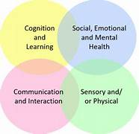
At Holy Trinity, we make provision for a variety of needs across the four SEND areas of need:
- Cognition and Learning
- Communication and Interaction
- Social, Emotional and Mental Health
- Sensory and Physical needs.
This includes ADHD, Autism, Diabetes, Downs Syndrome, Dyslexia, Dyspraxia, Epilepsy, visual impairment, hearing impairments and physical difficulties. We also make provisions for Speech and Language delay and pupils with Social, Emotional and Mental Health concerns. Working closely with parents and professionals we will always seek to put provision in place so that every child can achieve their full potential.
Section 2
How does the school know if pupils need extra help and what should I do if I think that my child may have special educational needs?
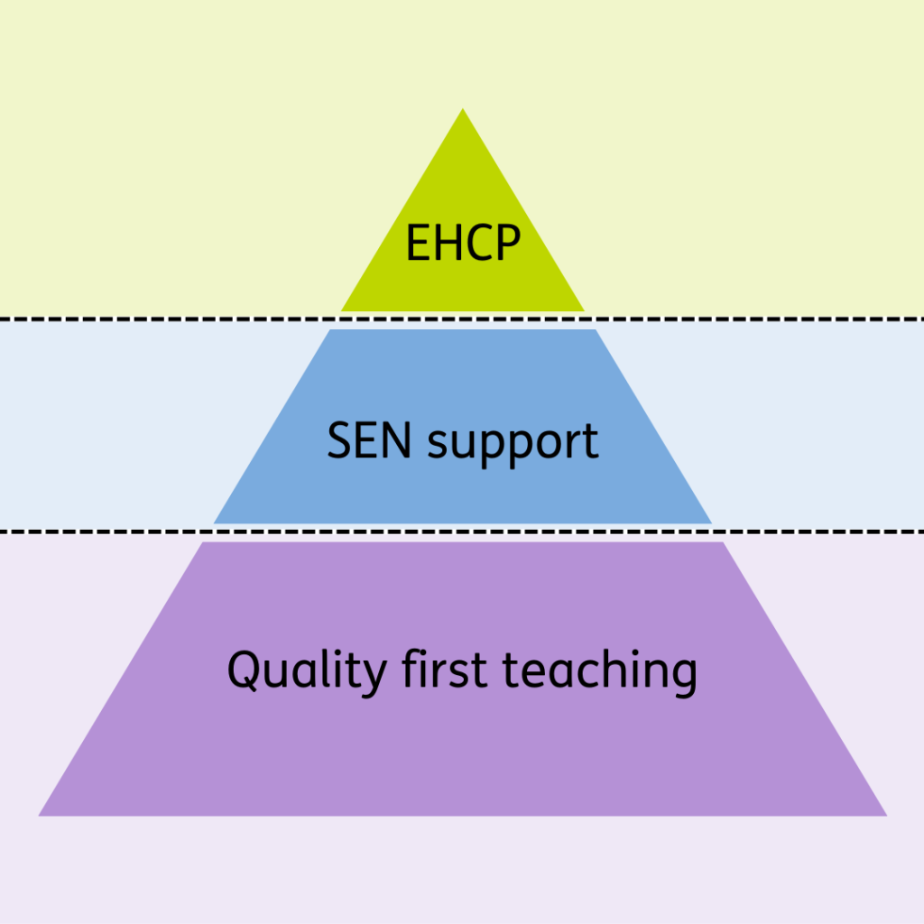
If a child is transferring from a different setting the school will be informed and a process put in place to ensure successful transition. Often, we will identify him or her through a clinical diagnosis that may be ongoing like Autism or through our own observations and assessment such as a dyslexia screener. Within school the progress of every child is carefully tracked and any concerns identified through these assessments, or professional observations will be raised with the parent by the class teacher. Similarly, a parent with concerns about their child should initially speak to their child’s class teacher who will stay in contact with the parent whilst looking into those concerns, in line with our graduated approach. The class teacher will discuss, decide, and record an action plan along with the SENDCo which will then be reviewed as regularly as required.

The graduated approach in more detail:

Quality First Teaching -teachers will:
• Make reasonable adjustments to support the child’s day.
• Assess regularly and look at the child’s progress.
• Consider delivery, adaptations and groupings during lessons.
• Plan for and assess the impact of interventions.
• Check that the learning environment meets the needs of all learners e.g. dyslexia and ASD friendly.
• Use visual timetables to support routines.
• Discuss with parents & carers any concerns they may have.
• Follow the school’s Behaviour Policy.
• Include pupils who they are concerned about on the School Aware List held by the SENDCo.
• Attend relevant staff training and inform SENDCo of any specific training needs.

If a child is under observation due to concerns by parents or the teacher, they may be recorded on the School Awareness List. If a child is having interventions or specific adaptations, the teacher and SENCo may feel it appropriate at this stage to have a PEN Portrait/Individual Provision Map in place and this would be reviewed termly, in discussion with parents.

If individual short-term intervention/adaptations are ineffective at meeting the needs of the pupil, higher level support will be offered. At this point, the pupil could be identified as needing Special Educational provision.

SEND Support – Where it is determined that a pupil does have SEND, parents will be formally advised of this, and the child will be placed on the school’s SEND Register. A pupil at SEND Support level will have a Pen Portrait, and usually an individual Provision map or an IEP (Individual Education Plan) which will be reviewed every term. Teachers will:
• Discuss concerns with the SENDCo (Leanne Evans) including the main area of need i.e. Cognition & Learning, Social, Emotional or Mental Health concerns, Communication & Interaction and Physical or Medical concerns.
• Arrange for the SENDCo to observe the pupil if needed.

Assess, Plan, Do, Review cycle (APDR) At the point in which the pupil is considered SEND Support the assess, plan, do, review cycle will begin and be reviewed termly. The reviews will be child-centered and will involve the child, parent and class teacher. The SENDCo may also be involved if needed.

Outside agency involvement - The SENDCo, with permission from parents/carers, may arrange for further assessments to be carried out by external professionals. These may include Early Health Assessment Framework (EHAF), Neurodevelopmental Behaviour Support Services (NBS), School and Families Specialist Service (SFSS), Health Related Education Team (HRET), Educational Psychologist, Schools Behaviour and Attendance Partnership (SBAP). Outside agencies will give advice on support measures to the class teacher and liaise with the SENDCo. The support measures will be put in place and the APDR cycle will continue.

Multi-agency Meeting - If necessary, a multi-agency meeting will be arranged by the SENDCo to coordinate the appropriate support for a pupil. This will include parents, class teacher and all agencies involved with the pupil. Notes will be kept, and next steps decided upon and actioned.

Additional funding - AFN/HFN bids for extra funding will be written by the SENDCo with information and assessment supplied by the class teacher. AFN bids are moderated at Family level, and HFN bids go to a county panel.

EHCP – Education Health Care Plan. If there is an overall agreement from all involved that the needs of the child are complex, severe, long term and impacting on everyday life and/or the headteacher believes that the placement of the child in the school should be assessed/considered then an EHCP request can be made. An EHCP request will be completed by the parents, SENDCo and any outside agencies involved with the pupil. An EHCP is a statutory document stating the individual needs of a pupil and how these should be met. If granted the EHCP cycle begins. The SENDCo will coordinate and chair the EHCP review and relevant meetings.

SEND Local Offer - provided by the Local Authority.
Section 3
How does the school evaluate the effectiveness of its provision for pupils with special educational needs?
Your child’s progress will be closely monitored by their class teacher. Their progress will be reviewed formally with the teacher and SENDCo every term. Where it is determined that a pupil does have SEN, parents will be formally advised of this. The aim of formally identifying a pupil with SEN is to help school ensure that effective provision is put in place and so remove barriers to learning. The support provided consists of a four-part process: Assess – Plan – Do – Review

This is an on-going cycle to enable the provision to be refined and revised as the understanding of the needs of the pupil grows. This cycle enables the identification of those interventions and types of adaptive practice which are the most effective in supporting the pupil to achieve good progress and outcomes.


Assess -This involves clearly analysing the pupil’s needs using the class teacher’s assessment and experience of working with the pupil, details of previous progress and attainment, comparisons with peers and national data, as well as the views and experience of parents. The pupil’s views and where relevant, advice from external support services will also be considered. Any parental concerns will be noted and compared with the school’s information and assessment data on how the pupil is progressing. This analysis will require regular review to ensure that support and intervention is matched to need, that barriers to learning are clearly identified and being overcome, and that the interventions being used are developing and evolving as required. Where external agency staff are already involved their work will help inform the assessment of need. Where they are not involved, they may be contacted, if this is felt to be appropriate, following discussion and agreement from parents.
Plan -Planning will involve consultation between the teacher, SENDCo and parents to agree the adaptations, adjustments, interventions and support that are required; the impact on progress, development and or behaviour that is expected and a clear date for review. Parental involvement may be sought, where appropriate, to reinforce or contribute to progress at home. All those working with the pupil, including support staff will be informed of their individual needs, the support that is being provided, any teaching strategies and approaches that are being employed and the outcomes that are being sought.
Do -The class teacher remains responsible for working with the child on a day-to-day basis. They will retain responsibility even where the interventions may involve group or one-to-one teaching away from the main class teacher. They will work closely with teaching assistants and /or relevant specialist staff to plan and assess the impact of support and interventions and links with classroom teaching. Support with further assessment of the pupil’s strengths and weaknesses, problem solving and advising of the implementation of effective support will be provided by the SENDCo.
Review -Reviews will be undertaken in line with agreed dates. The review process will evaluate the impact and quality of the support and interventions. It will also take account of the views of the pupil and their parents. The class teacher, in conjunction with the SENDCo will revise the support and outcomes based on the pupil’s progress and development, making any necessary amendments going forward, in consultation with parents and the pupil. Parents will be provided with clear information about the impact of support to enable them to be involved in planning the next steps. Where necessary, children will have a PEN Portrait, and individual targets will be set to enable your child to make specific progress. These targets will be reviewed regularly, will be evidence for judgements assessed and a plan made. Parents and pupils will be consulted on a regular basis to ensure that all are happy with the provision that is in place and that discussions have taken place to ensure that all know the most effective means of support. The progress of children with an EHC Plan will be formally reviewed at an Annual Review with all adults involved with the child’s education. The SENDCo will also check that your child is making good progress within any individual sessions or groups that they take part in. Regular book looks and learning walks will be carried out by the SENDCo to ensure that the needs of all children are met and that the quality of teaching and learning is high.

How will both the school and I know how my child is doing and how will the school help me to support their learning?
All children at Holy Trinity School are set ambitious, achievable targets in all areas of their learning. Throughout the year there are Parents’ Evenings and end of year reports. Where a child has an Individual Provision Map/IEP/EHCP/there are reviews each term, but all teachers are happy to talk to any parent about their child and additional meetings can be arranged at mutual convenience. Meetings can include the SENDCo, and this can also be arranged through the class teacher.

What is the school’s approach to teaching pupils with special educational needs?
As a school we believe in quality first teaching. We seek to deliver a broad, balanced, engaging and fully inclusive curriculum so that all children are given the opportunity to reach their potential and see themselves as learners. Appropriate interventions are put into place for any child, with or without special educational needs, who are not making expected progress. We support pupils with special educational needs and disabilities by providing specifically prepared learning materials and the use of appropriate ICT equipment. Children are taught with support in whole class situations where possible, or in small groups or one to one work. Specialist equipment and resources are used when requested by specialists and training undertaken by staff. As discussed previously, there is a graduated response to a child’s needs depending on the complexity of the need; outside support and expertise is sought from outside agencies available by the SENDCo attending a multiagency meeting called Springboard that are held throughout the year. Parents are consulted about all choices that are made concerning their child.

How will the curriculum and learning be matched to my child’s needs?
Every class teacher is responsible for the learning in their classroom; the delivery of the curriculum is adapted to cater for the varying abilities and learning styles of the children in the class. The approach to teaching children with special educational needs and disabilities listed above is employed when the need of a child is outside the regular parameters seen within a class.

How are decisions made about the type and amount of support my child will receive?
All decisions about the type and amount of support that children receive will be an ongoing collaboration between the child, parent, class teacher, SENDCo, outside agencies, Senior Leadership Team, Head Teacher and Governors and funding structures. For example, Minster Family Funding and HLN panel. Working closely with parents and professionals we will always seek to teach every child so they can achieve their best; the type and level of support remains fluid depending on the specific needs of the child at any particular time. If the needs and required provision meets the criteria for additional funding from an outside source, then a bid for that funding will be written by the SENDCo to further aid the support for that individual child

How will my child be included in activities outside the classroom, including trips?
All children are included in school activities and trips. Where children have additional needs there will be child specific risk assessments completed and adequate support put in place to ensure a safe and successful trip for all.

What support will there be for my child’s overall well-being?
All those who work in Holy Trinity School strive to foster warm, positive relationships with the children. The children are encouraged to discuss any issues they have, whether educational or social, with their class teacher or another adult. We have a member of staff who is trained as an Emotional Literacy Support Assistant (ELSA). This support can be accessed by children who might need some extra emotional support or benefit from small group work.

Section 4
Who is the school special educational needs coordinator (SENDCo) and what are their contact details?
Miss Leanne Evans is the school SENDCo. She can be contacted through the school office:
Email: office@southwellholytrinity.org.uk Tel: 01636 812067
If you have concerns about your child’s progress, you should speak to your child’s class teacher initially.
The school SEND Governor, Mrs Christine Cross, can also be contacted for support via the office.
Section 5
What training have staff supporting special educational needs had and what is planned?
The school provides training and support to enable all staff to improve the teaching and learning of all children, including those with SEND. Training includes Autism Awareness, Speech and Language, Zones of Regulation, Adaptive Practice, ELSA, Draw and Talk, Trauma Informed Practice.
This coming year our teachers have access to several SEND hot topic sessions being delivered through our trust, our TAs have access to a TA Send Network that will meet 3 times during the year to explore SEND issues, and they will also attend a TA SEND programme being delivered through our trust.
Individual teachers and support staff may also attend training courses run by outside agencies that are relevant to the needs of specific children in their class.

What specialist services and expertise are available or accessed by the school?

The following professional agencies can be accessed through a referral process:
• Schools & Families Specialist Support Services (SFSS) via referral by the SENCO.
- Physical Disability Support Service (PDSS)
- Hearing Impaired Service
- Visual Impaired Service
- Communication and Interaction team
- Cognition and Learning Team.
- Educational Psychology Service (EPS)
- Virtual School
- Targeted Support. Information can be obtained from the help desk of the Early Help Unit 01623 433500. Referral is usually needed by either Education, Health or Social Care professionals.
- Child Health Services obtained via local Health Centre. You may already have a GP you can talk to initially.
- Community Child Health Nurse accessed via local Health Centre. Your GP or our School Nurse can help with this.
- Clinical Psychiatrist via CAMHS – Child & Family Therapy can be via referral from Local GP, Community Health Nurse, Community Paediatrician or School.
- Occupational Therapy Services via referral from Local GP, Community Health Nurse, Community Paediatrician or School.
- Social Care
- Voluntary Sector agencies: we also value the support of the voluntary sector, e.g. Autism East Midlands.
Further details of local specialist services can be obtained through the Local Authority's Local Offer: www.nottinghamshire.sendlocaloffer.org.uk.

Section 6
How will equipment and facilities to support pupils with special educational needs secured? How accessible is the school/setting?
We have one disabled toilet in school with handrails. We ensure wherever possible that equipment used is accessible to all children regardless of their needs. After-school provision is accessible to all children, including those with SEND. All current extra-curricular activities are accessible for children with SEND.
Section 7
What are the arrangements for consulting parents of pupils with special educational needs? How will I be involved in the education of my child?
The class teacher is regularly available to discuss your child’s progress or any concerns you may have, and to share information about what is working well at home and school, so that similar strategies can be used. The SENDCo is available to meet with you to discuss your child’s progress or any concerns/worries you may have. All information from outside professionals will be discussed with you, with the person involved directly, or where this is not possible, in a report. Personal progress targets will be reviewed with your involvement every term. Homework will be adjusted as needed to your child’s individual requirements. A home-school contact book may be used to support communication with you when this has been agreed to be useful for you and your child.
Section 8
What are the arrangements for consulting young people with SEN and involving them in their education?
We value and celebrate each child being able to express their views on all aspects of school life. This is usually carried out through circle time activities and Playing and Learning groups (PAL groups) which has an open forum for any issues or viewpoints to be raised. If your child has an IEP, Individual provision map or EHCP, their views will be sought before any review meetings.
Section 9
What do I do if I have a concern or complaint about the SEND provision made by the school?
If you have a concern or complaint, please contact the Headteacher and we will endeavour to work with you to resolve the issue. Our school and governing body take complaints seriously and will act upon these on an individual basis. Please look at the school complaints procedures on the website:
www.southwellholytrinity.org.uk
Section 10
How does the governing body involve other organisations and services (e.g. health, social care, local authority support services and voluntary organisations) in the meeting the needs of pupils with special educational needs and supporting the families of such pupils?
The school SEND Governor is Mrs Christine Cross. Her role is to meet with the SENDCo termly. In these meetings the SEND Governor makes sure that children and families are being supported by the right services from in and outside of school. The SEND Governor may also visit the school, observe what happens in classrooms and meet with class teachers, support staff and children. The SENDCo reports to the Governors annually to inform them about the progress of children with SEND; this report does not refer to individual children and confidentiality is maintained at all times.
Section 11
How does the school seek to signpost organisations, services etc. who can provide additional support to parents /carers/young people?
The SENDCo can signpost parents to the wide range of support organisations and groups available in the community. As discussed above the SENDCo can also access the professionals that can offer the specific support required for the child’s needs; either to work directly with the child or to offer advice to parents or staff. The school website is a resource that can be used by parents of children with Special Educational Needs and Disabilities; it is updated regularly with new information. The School Nurse is available to add expertise and signposting that is more specifically related to health and mental wellbeing; this service can be accessed by the SEND team.
Section 12
How will the school prepare my child to: Join the school? Transfer between phases of education (e.g. between early years to Key Stage 1)? Transfer to Key Stage 2?

We recognise that transitions can be difficult for a child with SEND, and we take steps to ensure that any transition is a smooth as possible.
If your child is joining us from another school -The SENDCo will visit pre-schools with the Foundation Stage Leader when appropriate. If your child would be helped by a book/passport to support them in understanding moving on, one will be made for them. Your child will be able to visit our school and stay for at least three taster sessions, or more as appropriate.
If your child is moving to another school - We will contact the school SENDCo and ensure they know about any special arrangements or support that need to be made for your child. Where possible, a planning meeting will take place with the SENDCo from the new school. We will make sure that all records about your child are passed on as soon as possible. If your child would be helped by a book/passport to support them in understanding moving on, one will be made for them.
When moving classes in school - Information will be passed on to the new class teacher in advance and in most cases a planning meeting will take place with the new teacher. Individual provision will be shared with the new teacher. If your child would be helped by a book/passport to support them in understanding moving on, then one will be made for them.
Section 13
Where can I access further information?
Please visit our website to find more information about the school.
The Local Authority provides a framework to support schools in carrying out their duties. Nottinghamshire has a Local Offer as required by the SEN Code of Practice (2015) which has two key purposes:
• To provide clear, comprehensive and accessible information about the provision available locally; and • To make provision more responsive to local needs and aspirations by directly involving children and young people with SEN, parents and carers, and service providers in its development and review.

Please visit www.nottinghamshire.sendlocaloffer.org.uk for more details.
The Integrated Children’s Disability Service (Nottinghamshire County Council) also advise parents/carers with regards to EHC Plans and Assessments. They can be contacted on. Icds.duty@nottscc.gov.uk

In this document the term ‘parent’ includes all those with parental responsibility including carers.

